Blackjack Analysis

Brief Summary:

Before our project began, we wanted to build a simulation where an simulation output is able to provide us with numbers and plots that can show at under what condition, will we see an optimal play setting a player can have to maximize his winning ratio in a Blackjack game. To do this, we had based our analysis with changing variables such as the play style of the player, number of people on table, number of deck being used, and starting confidence level of the player. Using the graphical representation of the data, and comparing difference simulation, we were able to get an answer to the questions we had starting this simulation.

Under what condition does player have the best chance to earn more chips?

After running the simulation multiple times, we had observed which if a player plays randomly, they will more than likely lose more chips compared to playing normally or playing with odd. This is clearly evident as our If the player plays the game normally, then there isn’t much variance in win or losing the chip. Finally, If the player plays with Odds, then they have the higher chance of winning the game. An interesting result that we found is that depending on the moods of the player (confidence level) in our analysis, the player’s chip also change as well. Player with a small confidence level usually does not deviate much from his/her chips. However, player with a high confidence level tends to earn a lot more chip (double) but at the same time, also lose more chip. This matches with our view of the world when playing Blackjack in the cases where a player play safe, or a player play in a fierce way,

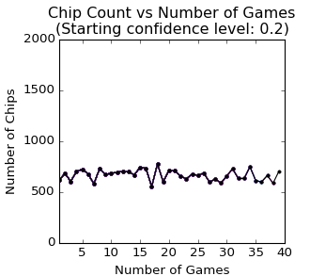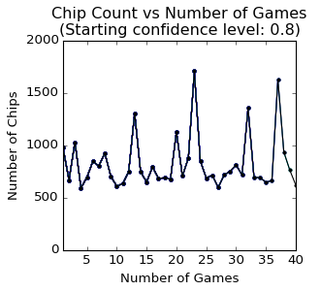

At what condition, gives the most consistent play of blackjack with 50/50 win-loss ratio?

Playing with Odds gives the most consistent play of blackjack. As the number of simulations or number of games increases, playing with odds approximate roughly 45 - 50%. This ratio does not change much during multiple games. However, the playing with random once produced a result of 0.8 win ratio in one game. However, it is very rare and it is considered an outlier. This can be translated in real-life where the player is extremely lucky and his random choice continues to win, which is very rare

Below are some images of different variations of the game such as different play style, different rounds or simulations

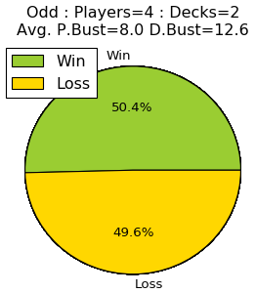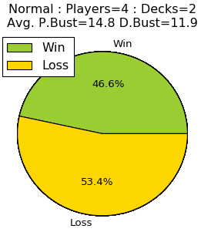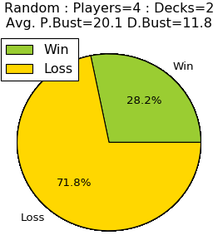

Does the number of rounds affect the number of wins?

From the graph below, we see that as the number of rounds increases, the number wins also increase. For example, at round 5 the number of wins is 2 whereas at round 20 the number of wins is 10. An interesting fact is that the relationship approximate a positive linear line.

Representing a positive correlation between number of rounds and number of wins. We believe that as we play more, we tend to win more. However, we also need to consider factors such as the chips we lost versus the chips we gain to conclude that we are making progress.

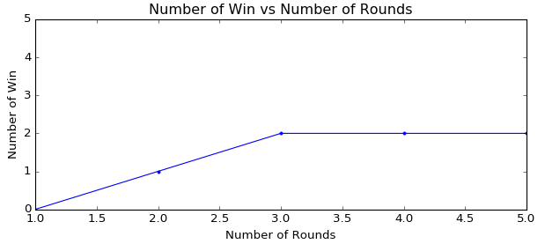

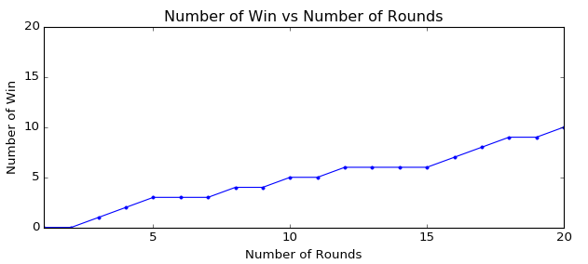

Which of these conditions gives the player the best chance of not going bust, when the dealer has a chance of going bust?

Out of the three conditions, if the Player plays *with Odd* then the Player has the best chance of not going bust when compared to normal and random. The Player will most likely go bust using the play random method and the player will have the lowest chip earns.



Variation of Simulation:

Playing Style = Odd, Odd, Random, Normal

Number of Players: 4

Number of Decks: 4

Number of games: 20

Number of rounds: 20

Confidence level: 0.5

Figure: Running the simulations with different play styles

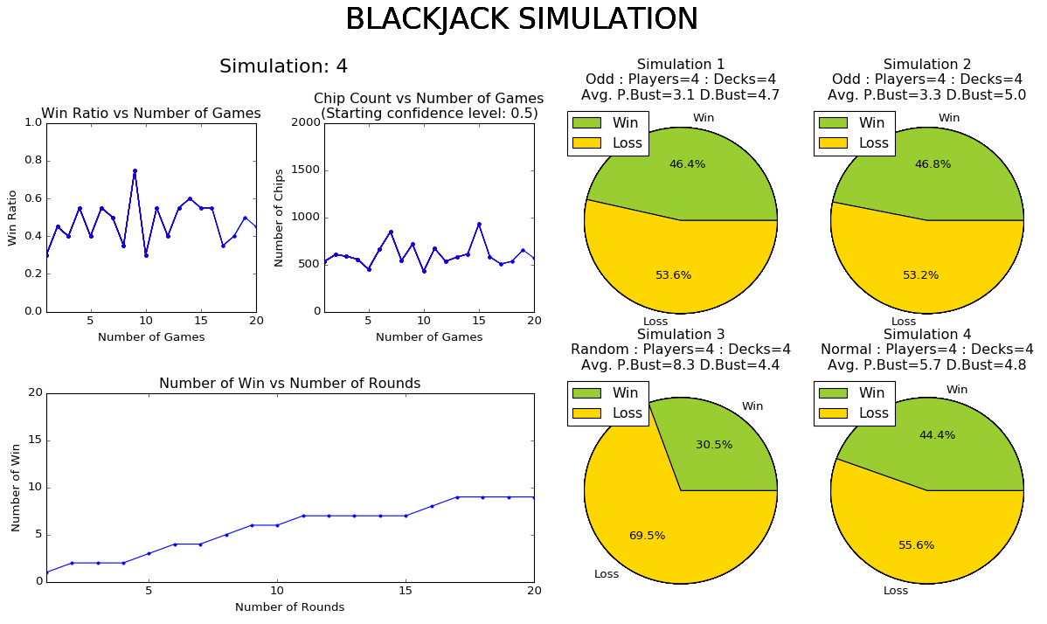

Variation of Simulation:

Playing Style = Odd, Odd, Random, Normal

Number of Players: 4

Number of Decks: 2

Number of games: 20

Number of rounds: 20

Confidence level: 0.5

Figure: Running the simulations with different play styles

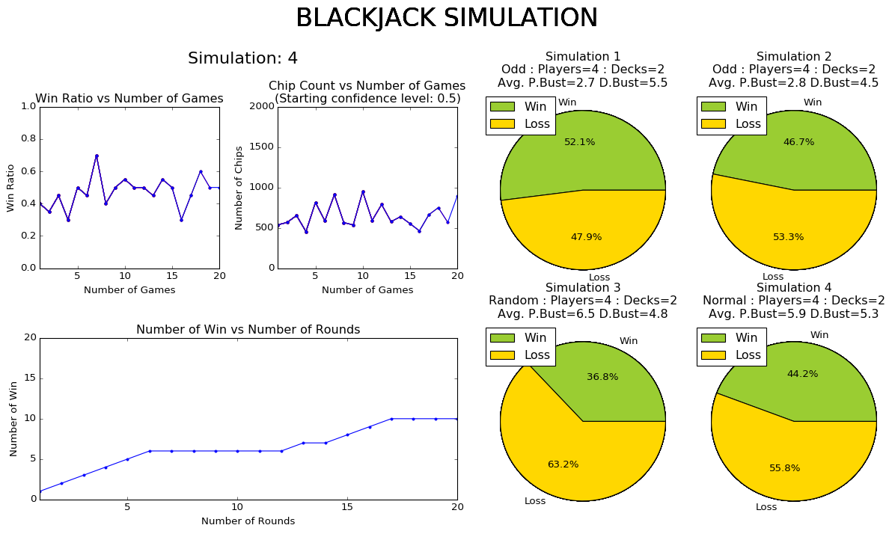

Variation of Simulation:

Playing Style = Odd

Number of Players: 1, 2, 3, 4

Number of Decks: 2

Number of games: 20

Number of rounds: 20

Confidence level: 0.5

Figure: Simulation with 4 different number of players

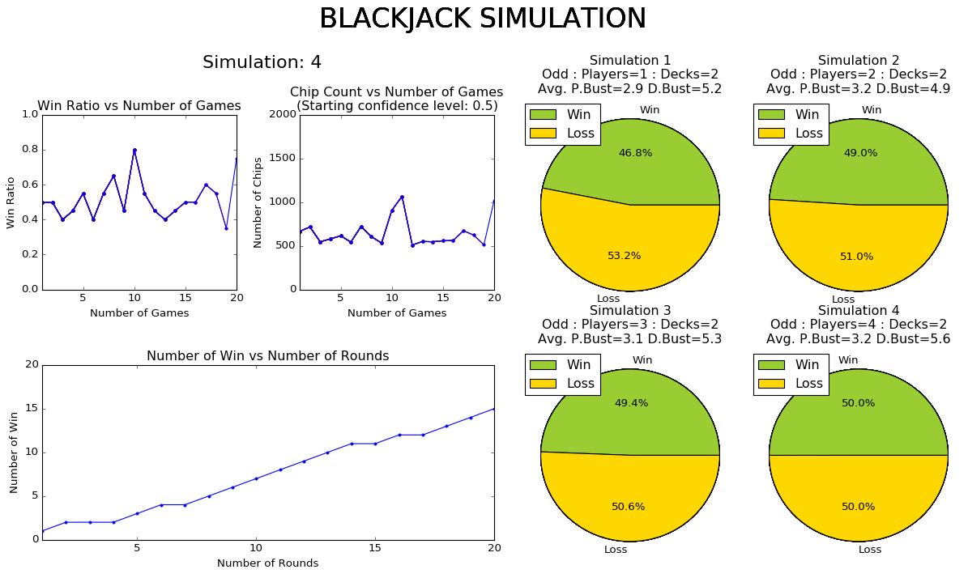

Variation of Simulation:

Playing Style = Odd

Number of Players: 4

Number of Decks: 2, 3, 4, 5

Number of game: 20

Number of rounds : 20

Confidence level: 0.5

Figure: Simulation with 4 different deck sizes

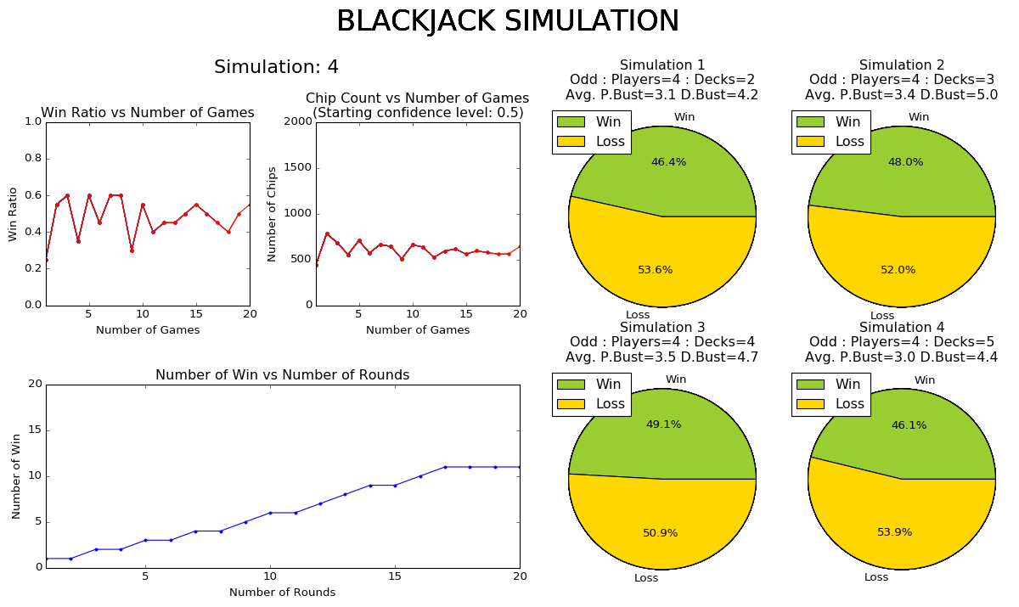

Variation of Simulation:

Playing Style = Odd

Number of Players: 4

Number of Decks: 2

Number of game: 20

Number of rounds : 20

Confidence level: 0.2, 0.4, 0.6, 0.8

Figure: Simulation with 4 different confidence level

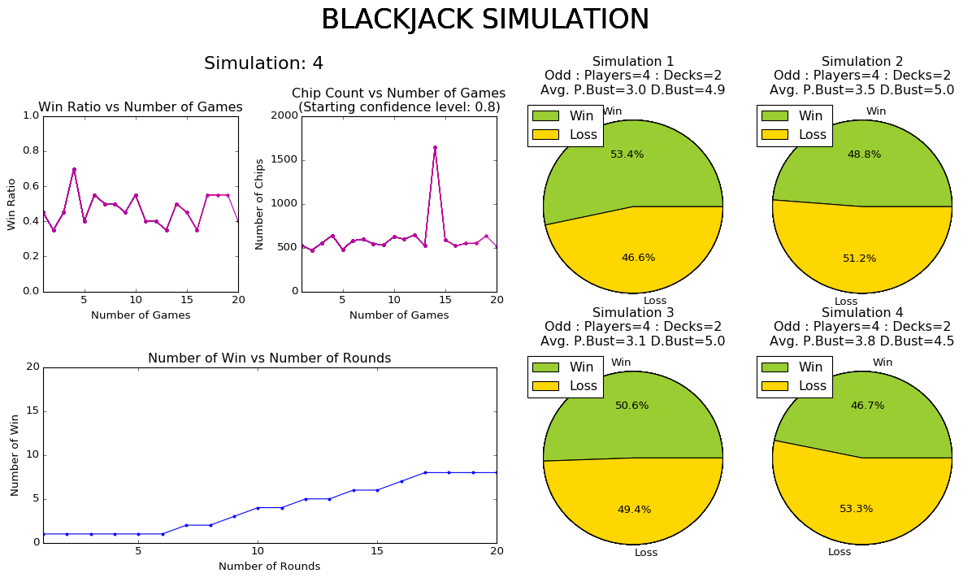

Variation of Simulation:

Playing Style = Odd

Number of Players: 4

Number of Decks: 2

Number of game: 20

Number of rounds : 50, 100, 150, 200

Confidence level: 0.5

Figure: Simulation with 4 different number of rounds

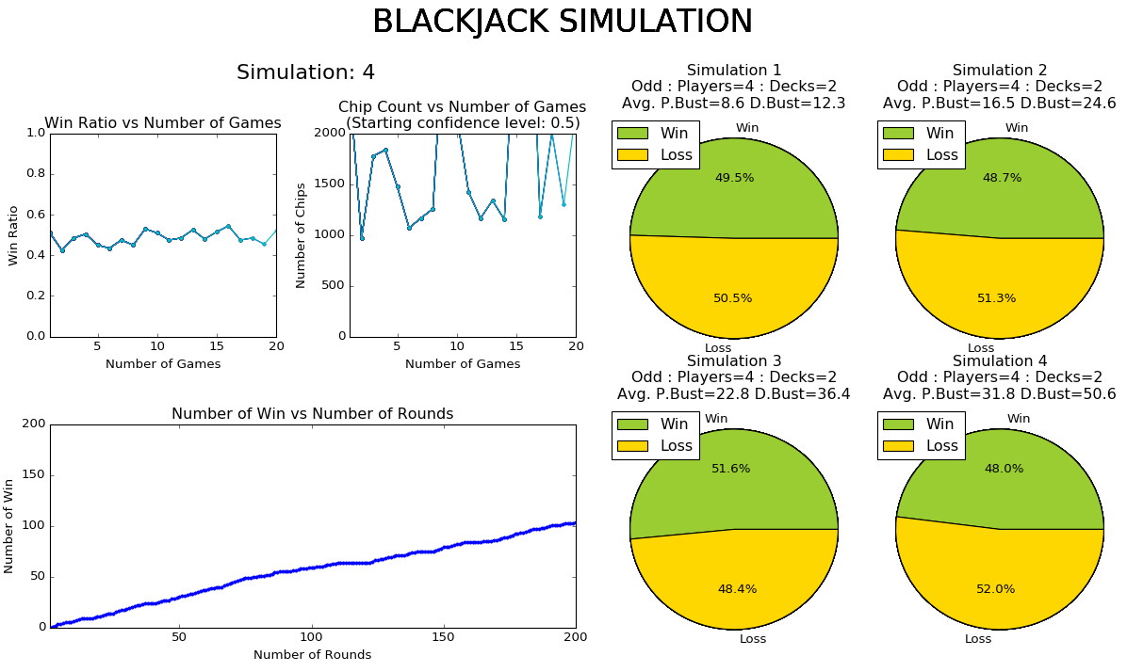

Variation of Simulation:

Playing Style = Odd

Number of Players: 4

Number of Decks: 2

Number of game: 50, 100, 150, 200

Number of rounds : 20

Confidence level: 0.5

Figure: Simulation with 4 different number of games

REFERENCES

https://www.blackjackincolor.com/truecount5.htm